TCS-Net
Patient-Specific Temporal Cross-Antibiotic
Susceptibility Modeling
CBIO313 - Data Mining & Machine Learning
Student Name: Abdalrahman Abdo
Student ID: 231001347
Instructor: Dr. Muhammad Elsayeh

Abstract
Antimicrobial resistance makes empirical antibiotic selection difficult, especially in patients with recurrent infections. This project investigated whether antimicrobial susceptibility results from a patient's previous Escherichia coli urine culture can help predict resistance in a later recurrent culture. The proposed model, TCS-Net, combines previous same-drug susceptibility, cross-antibiotic susceptibility information, time between cultures, and explicit temporal interaction features.
The primary analysis focused on Ciprofloxacin resistance using longitudinal Stanford microbiology data. Logistic Regression, Decision Tree, and Random Forest were evaluated as standard machine-learning models. TCS-Net was then compared with a same-drug temporal baseline and an additive cross-antibiotic model. Temporal validation, new-patient evaluation, cross-target replication using Ampicillin, and independent external validation using UTSW data were performed.
In Stanford temporal validation, TCS-Net achieved ROC-AUC 0.8737 compared with 0.8235 for the same-drug temporal baseline. The interaction model also improved performance for Ampicillin and remained better than the simpler baselines during independent UTSW validation. A Smart-AST abstention layer was developed to avoid forcing predictions in uncertain cases. The results support the presence of useful patient-specific temporal cross-antibiotic predictive information, while also showing that calibration and operating thresholds may shift between clinical sites.

1. Introduction
Antimicrobial susceptibility testing (AST) is used to determine whether a bacterial isolate is susceptible or resistant to specific antibiotics. In routine practice, the definitive AST result is not immediately available when a new culture is collected. Previous microbiology results from the same patient may therefore contain useful information about the likely susceptibility pattern of a recurrent isolate.
A simple prediction strategy could use only the patient's previous result for the same antibiotic. However, resistance patterns across antibiotics are related, and the usefulness of an old result may change as more time passes between cultures. This project investigates whether explicitly modeling these cross-antibiotic and temporal relationships improves prediction.
The project focuses on recurrent E. coli urine cultures. It does not assume that two isolates from the same patient are the same bacterial strain, and the analysis is predictive rather than causal.

2. Project Objectives
- Construct a longitudinal cohort of recurrent E. coli urine cultures.
- Examine how previous susceptibility relates to susceptibility in a later culture.
- Study how the predictive value of previous AST changes with time.
- Compare Logistic Regression, Decision Tree, and Random Forest models.
- Develop an interaction model that combines same-drug, cross-antibiotic, and temporal information.
- Evaluate the model using temporal and new-patient validation.
- Replicate the modeling approach using Ampicillin as a second prediction target.
- Test model transportability on an independent UTSW dataset.
- Add an uncertainty-aware abstention layer for research demonstration.
- Use SHAP and model coefficients to inspect model behavior.

3. Datasets

3.1 Stanford ARMD
The main development dataset was the Stanford Antibiotic Resistance Microbiology Dataset (ARMD), distributed through Dryad. The raw microbiology table contains longitudinal culture and antimicrobial susceptibility records.
The primary analysis used positive urine cultures containing E. coli and directly measured Susceptible or Resistant AST results. After preprocessing and temporal transition construction, 20,368 valid consecutive culture transitions from 9,307 recurrent patients were available.

3.2 UTSW External Dataset
An independent microbiology dataset from UT Southwestern (UTSW) was used for external validation. The UTSW raw table contained 1,893,548 records from 237,258 patients. The same main cohort rules used for Stanford were applied to UTSW.
After preprocessing, 11,801 valid recurrent culture transitions from 5,813 patients were available. Stanford-trained models were applied directly to the UTSW data without UTSW-specific retraining for the primary external transport evaluation.

4. Data Preprocessing
The preprocessing pipeline was designed to create one transition from a previous culture to the next culture for the same patient.
- Selected positive urine cultures.
- Restricted the organism to Escherichia coli.
- Used directly measured AST results only.
- Kept Susceptible and Resistant outcomes.
- Removed conflicting culture-antibiotic results.
- Collapsed repeated identical AST results.
- Selected patients with at least two distinct cultures.
- Created one AST matrix row per culture.
- Sorted cultures chronologically within each patient.
- Created consecutive previous-to-next culture transitions.
- Removed transitions separated by 14 days or less.
Time between cultures was divided into five categories: 15-90 days, 91-180 days, 181-365 days, 366-730 days, and more than 730 days.

5. Exploratory Data Analysis
Exploratory analysis showed that the previous result of the target antibiotic was strongly associated with the result of the later culture. For Ciprofloxacin, patients whose previous result was Resistant had a much higher probability of future resistance than patients whose previous result was Susceptible.
The strength of this association changed with time. When previous Ciprofloxacin was Resistant, the future resistance rate was about 92.1% at 15-90 days and decreased to about 46.6% after more than 730 days. When previous Ciprofloxacin was Susceptible, future resistance increased from about 6.8% at 15-90 days to about 13.1% after more than 730 days.
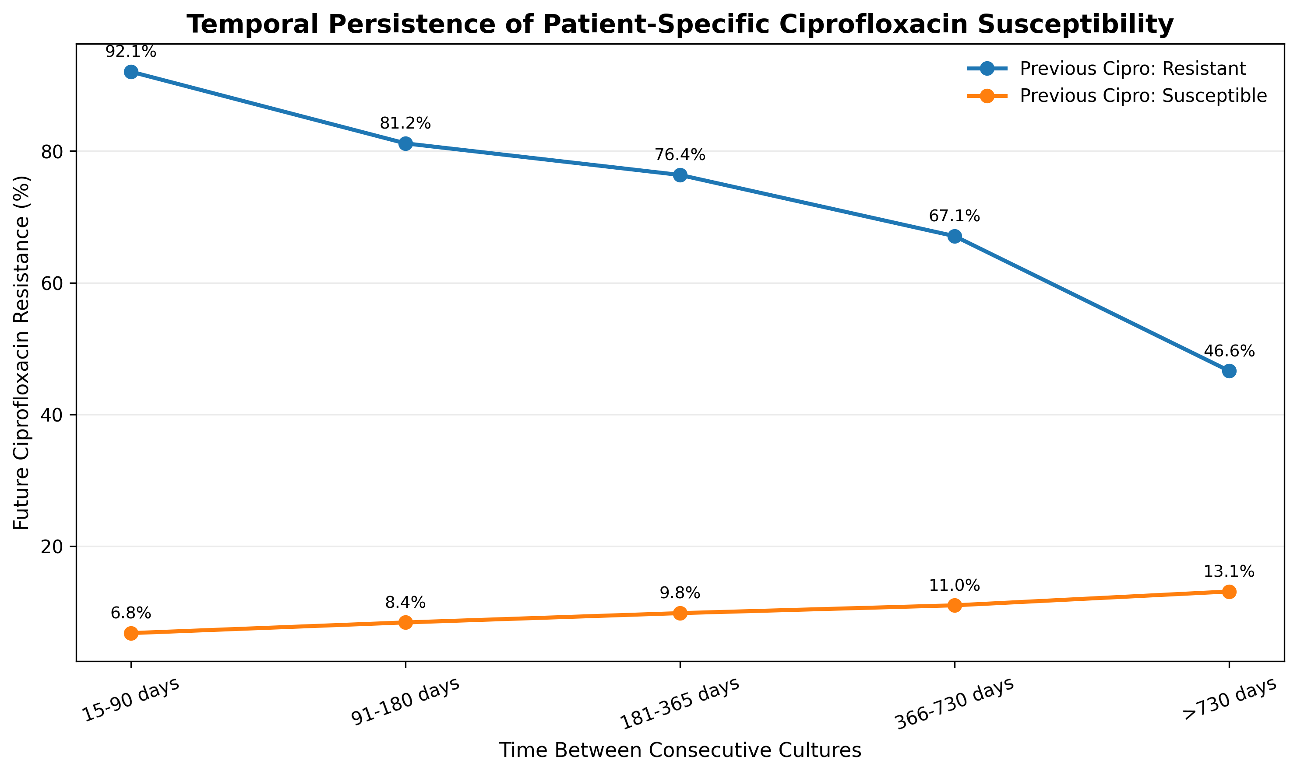
Figure 1. Temporal relationship between previous Ciprofloxacin susceptibility and future resistance.

6. Machine-Learning Methods

6.1 Standard Course Models
Three standard machine-learning algorithms were implemented and compared as part of the course requirements: Logistic Regression, Decision Tree, and Random Forest.
Patient-level splitting was used so that a patient did not appear in both training and test groups during the initial development comparison. This reduces leakage caused by repeated cultures from the same individual.

6.2 TCS-Net Feature Designs
The final analysis used three progressively richer feature sets.
- B2: previous same-drug susceptibility and time window.
- D2: B2 features plus previous susceptibility to other antibiotics.
- TCS-Net interaction model: D2 features plus explicit interactions between previous target-drug status, another antibiotic status, and time window.
For the Ciprofloxacin model, cross-antibiotic features included Ampicillin, Trimethoprim/Sulfamethoxazole, Gentamicin, Cefazolin, and Ceftriaxone.

7. TCS-Net Interaction Model
The main motivation for the interaction model was that a cross-antibiotic result may have different predictive meaning depending on the previous target-drug result and the time since the previous culture.
For example, an interaction can represent the combination of previous Ciprofloxacin Resistant, previous Ceftriaxone Susceptible, and a 15-90 day time interval. The model therefore learns separate weights for clinically different combinations rather than assuming that each feature has the same additive effect in every situation.
The final TCS-Net classifier used regularized Logistic Regression with one-hot encoded categorical and interaction features.

8. Model Evaluation Strategy
- ROC-AUC was used to evaluate discrimination.
- PR-AUC was included because resistance prevalence was not balanced.
- Brier Score was used to evaluate probabilistic prediction quality.
- Accuracy, precision, recall, specificity, and F1 were also calculated.
- Patient-level bootstrap resampling was used to calculate confidence intervals for model improvements.
- Temporal validation used earlier years for training and 2022-2023 for final evaluation.
- A new-patient analysis evaluated patients not observed in the historical training period.
- Ampicillin was used as a locked second-target replication.
- UTSW was used as an independent external-site validation set.

9. Results

9.1 Ciprofloxacin - Stanford Temporal Validation
Model | ROC-AUC | PR-AUC | Brier Score
B2 | 0.8235 | 0.7462 | 0.1070
D2 | 0.8262 | 0.7556 | 0.1067
TCS-Net | 0.8737 | 0.7840 | 0.1017

TCS-Net improved ROC-AUC by 0.0501 compared with B2. The patient-level bootstrap 95% confidence interval for this improvement was 0.0361 to 0.0648. PR-AUC improved by 0.0380, and Brier Score improved by 0.0053.

9.2 Ampicillin - Locked Cross-Target Replication
Model | ROC-AUC | PR-AUC | Brier Score
B2 | 0.7720 | 0.7681 | 0.1804
D2 | 0.7733 | 0.7784 | 0.1792
TCS-Net | 0.8230 | 0.8048 | 0.1680

The same interaction design also improved Ampicillin prediction. The TCS-Net regularization setting was transferred from the Ciprofloxacin development process without Ampicillin-specific tuning.

9.3 Independent UTSW Validation
Ciprofloxacin external validation:
Model | ROC-AUC | PR-AUC | Brier Score
B2 | 0.8263 | 0.7696 | 0.1354
D2 | 0.8292 | 0.7841 | 0.1350
TCS-Net | 0.8566 | 0.8001 | 0.1305

Compared with B2, TCS-Net improved external Ciprofloxacin ROC-AUC by 0.0303 (95% CI 0.0230 to 0.0377), PR-AUC by 0.0306, and Brier Score by 0.0049.
Ampicillin external validation:
Model | ROC-AUC | PR-AUC | Brier Score
B2 | 0.7613 | 0.7859 | 0.1931
D2 | 0.7623 | 0.7958 | 0.1925
TCS-Net | 0.7974 | 0.8152 | 0.1825

Compared with B2, TCS-Net improved external Ampicillin ROC-AUC by 0.0361 (95% CI 0.0298 to 0.0430), PR-AUC by 0.0293, and Brier Score by 0.0106.
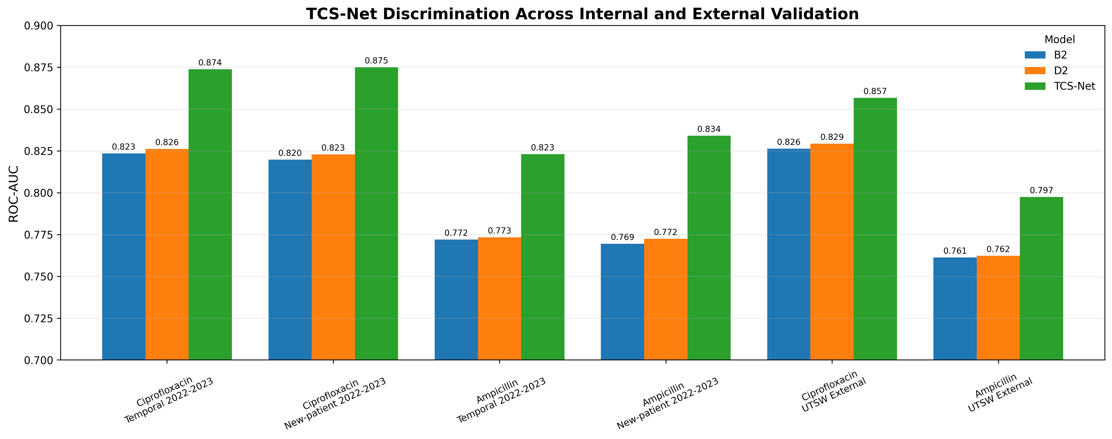
Figure 2. ROC-AUC across Stanford and UTSW validation settings.
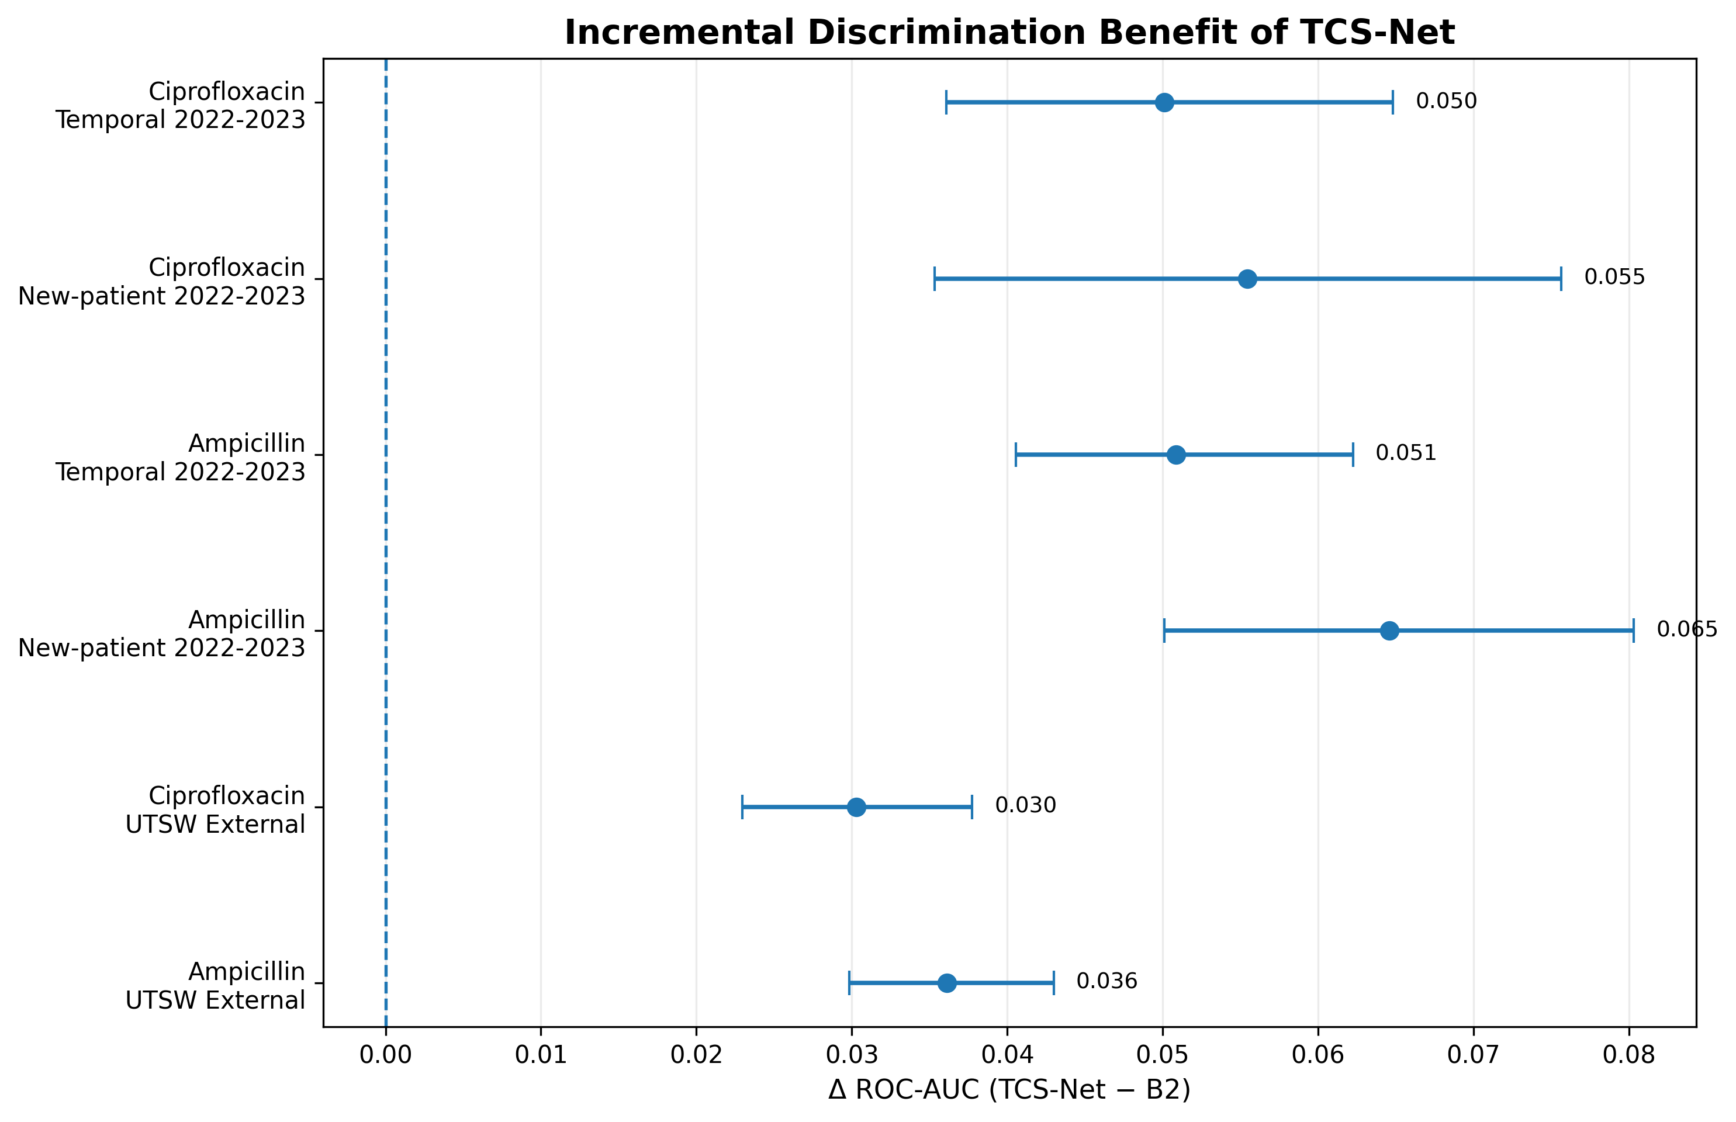
Figure 3. Patient-level bootstrap ROC-AUC improvement of TCS-Net over the same-drug temporal baseline.

10. Smart-AST Safety Layer
A probability-based abstention layer was added to the Ciprofloxacin model. Instead of forcing a classification for every sample, Smart-AST allows the model to return Laboratory AST Required when the calibrated probability lies in an uncertain region.
Calibrated P(Resistance) | Action
≤ 0.10 | Likely Susceptible
0.10 - 0.80 | Laboratory AST Required
≥ 0.80 | Likely Resistant

The thresholds were selected on Stanford development data as a research operating point. They are not clinically validated treatment thresholds.
On Stanford 2022-2023 data, Smart-AST achieved 61.1% coverage and 92.0% selective accuracy. On UTSW, coverage was 52.5% and selective accuracy was 90.0%. The false-susceptible rate increased from 7.15% at Stanford to 9.77% at UTSW.
The external calibration slope was 0.975 and the intercept was 0.154. This suggests that discrimination transferred better than exact probability calibration, and site-specific recalibration may be needed before any future deployment.
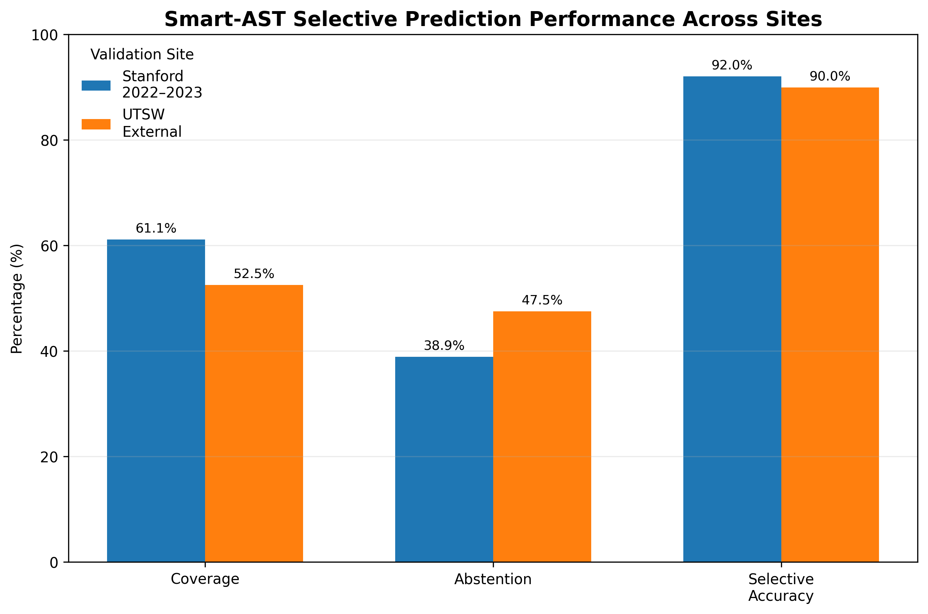
Figure 4. Smart-AST selective prediction performance at Stanford and UTSW.
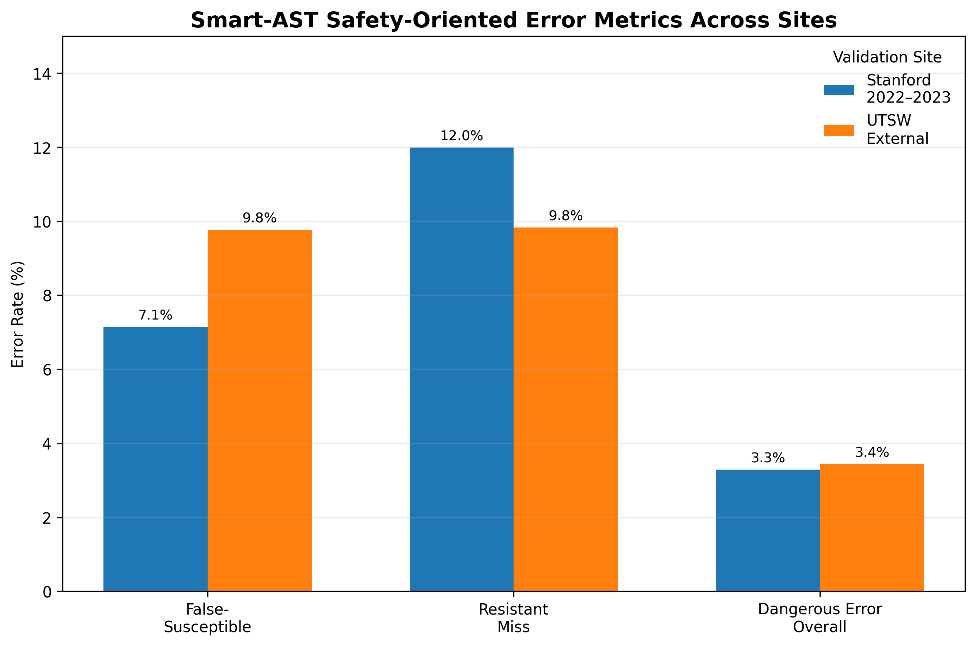
Figure 5. Smart-AST safety-oriented error metrics across sites.

11. Model Explainability
Model coefficients and SHAP values were used to inspect the fitted TCS-Net model. Previous Ciprofloxacin susceptibility was one of the strongest predictive features. Time features and several temporal cross-antibiotic interaction terms also contributed to the model predictions.
Because the model contains one-hot encoded categorical variables, interaction terms, and L2 regularization, coefficient values should be interpreted as predictive model weights rather than independent classical odds ratios. SHAP results describe how the model produces predictions and do not establish causal biological relationships.

12. Discussion
The main result of the project is that previous same-drug susceptibility alone does not capture all of the useful information available in a patient's previous AST profile. Explicit temporal cross-antibiotic interactions produced consistent improvements in Ciprofloxacin prediction and repeated the same pattern for Ampicillin.
The external UTSW results are important because the models were transferred from Stanford without site-specific retraining. TCS-Net remained better than both the same-drug temporal baseline and the additive cross-antibiotic model for both targets. This suggests that the predictive interaction structure is not limited to a single institution.
At the same time, the Smart-AST results showed that model discrimination and deployment calibration should be treated separately. Ranking performance remained strong externally, while the exact calibrated probabilities and abstention operating characteristics shifted. This is an important consideration for clinical machine-learning systems.

13. Limitations
- The same bacterial species in two cultures does not prove that the isolates are the same strain or lineage.
- The study is observational and cannot establish causal collateral-susceptibility mechanisms.
- AST missingness may be related to laboratory testing practices and may not be random.
- Clinical and laboratory practices may differ between institutions and across years.
- The analysis focuses on patients with recurrent cultures, which is a selected clinical population.
- The initial exploratory analysis involved multiple comparisons.
- External calibration showed some site-specific probability shift.
- The Smart-AST thresholds were selected for research demonstration and are not clinical cutoffs.

14. Conclusion
TCS-Net demonstrates that patient-specific temporal cross-antibiotic susceptibility information can improve prediction of resistance in recurrent E. coli urine cultures. The interaction model consistently outperformed simpler same-drug and additive baselines during temporal validation, new-patient testing, Ampicillin replication, and independent UTSW external validation.
The results support further investigation of longitudinal AST history as a predictive signal. Prospective evaluation and site-specific calibration would be required before considering any clinical use.

15. Data and Code Availability
The project code, final notebook, figures, exported result tables, trained demonstration model, and Streamlit application are organized in the TCS-Net GitHub repository.
Raw microbiology datasets are not included in the repository because of their size. The data directory contains information describing the original data sources.

References
1. Stanford Antibiotic Resistance Microbiology Dataset (ARMD). Dryad Digital Repository. DOI: 10.5061/dryad.jq2bvq8kp.
2. UT Southwestern Antibiotic Resistance Microbiology Dataset. Dryad Digital Repository. DOI: 10.5061/dryad.0rxwdbsd5.
3. Pedregosa F, et al. Scikit-learn: Machine Learning in Python. Journal of Machine Learning Research. 2011;12:2825-2830.
4. Lundberg SM, Lee SI. A Unified Approach to Interpreting Model Predictions. Advances in Neural Information Processing Systems. 2017.

